# **Unit -3**

# **Image Edge Detection Operators in Digital Image Processing**

Edges are significant local changes of intensity in a digital image. An edge can be defined as a set of connected pixels that forms a boundary between two disjoint regions. There are three types of edges:

* Horizontal edges
* Vertical edges
* Diagonal edges

**Edge Detection** is a method of segmenting an image into regions of discontinuity. It is a widely used technique in digital image processing like -

* pattern recognition
* image morphology
* feature extraction

Edge detection allows users to observe the features of an image for a significant change in the gray level. This texture indicates the end of one region in the image and the beginning of another. It reduces the amount of data in an image and preserves the structural properties of an image

**Edge Detection Operators** are of two types:

* **Gradient –** based operator which computes first-order derivations in a digital image like, Sobel operator, Prewitt operator, Robert operator
* **Gaussian –** based operator which computes second-order derivations in a digital image like, Canny edge detector, Laplacian of Gaussian

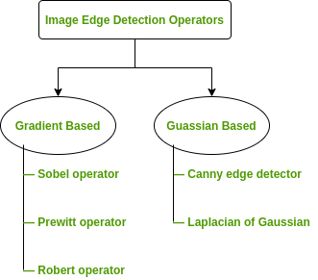

**Sobel Operator:** It is a discrete differentiation operator. It computes the gradient approximation of image intensity function for image edge detection. At the pixels of an image, the Sobel operator produces either the normal to a vector or the corresponding gradient vector. It uses two 3 x 3 kernels or masks which are convolved with the input image to calculate the vertical and horizontal derivative approximations respectively-



***Advantages:***

1. Simple and time efficient computation
2. Very easy at searching for smooth edges

***Limitations:***

1. Diagonal direction points are not preserved always
2. Highly sensitive to noise
3. Not very accurate in edge detection
4. Detect with thick and rough edges does not give appropriate results

**Prewitt Operator:** This operator is almost similar to the sobel operator. It also detects vertical and horizontal edges of an image. It is one of the best ways to detect the orientation and magnitude of an image. It uses the kernels or masks –



***Advantages:***

1. Good performance on detecting vertical and horizontal edges
2. Best operator to detect the orientation of an image

***Limitations:***

1. The magnitude of coefficient is fixed and cannot be changed
2. Diagonal direction points are not preserved always

**Robert Operator:** This gradient-based operator computes the sum of squares of the differences between diagonally adjacent pixels in an image through discrete differentiation. Then the gradient approximation is made. It uses the following 2 x 2 kernels or masks –



***Advantages:***

1. Detection of edges and orientation are very easy
2. Diagonal direction points are preserved

***Limitations:***

1. Very sensitive to noise
2. Not very accurate in edge detection

**Canny Operator:** It is a gaussian-based operator in detecting edges. This operator is not susceptible to noise. It extracts image features without affecting or altering the feature. Canny edge detector have advanced algorithm derived from the previous work of Laplacian of Gaussian operator. It is widely used an optimal edge detection technique. It detects edges based on three criteria:

1. Low error rate
2. Edge points must be accurately localized
3. There should be just one single edge response

***Advantages:***

1. It has good localization
2. It extract image features without altering the features
3. Less Sensitive to noise

***Limitations:***

1. There is false zero crossing
2. Complex computation and time consuming

**Some Real-world Applications of Image Edge Detection:**

* medical imaging, study of anatomical structure
* locate an object in satellite images
* automatic traffic controlling systems
* face recognition, and fingerprint recognition

### 

### **Edge Detection Techniques in Image Processing**

Edge detection is a fundamental technique in image processing used to identify boundaries within an image. Various operators (kernels) are used to detect edges, primarily based on first-order and second-order derivatives.

## **1. Roberts Kernel**

The **Roberts Cross Operator** is one of the simplest edge detection techniques based on **first-order derivatives**. It is a **2×2 convolution kernel** that responds to regions of high spatial gradient.

### **Roberts Operator Masks:**

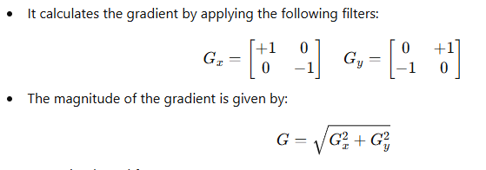

### **Properties:**

* Fast and simple to compute.
* Detects diagonal edges effectively.
* Sensitive to noise due to its small kernel size.

## **2. Prewitt Kernel**

The **Prewitt Operator** is another first-order derivative operator that emphasizes horizontal and vertical edges. It uses a **3×3 kernel**, providing better noise resistance than the Roberts operator. The **Prewitt operator** is similar to the **Sobel operator**, but uses equal weights for calculating the gradient.

The **3×3 convolution kernels** are:

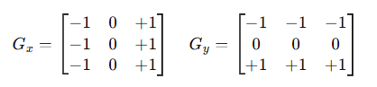

### **Prewitt Operator Masks:**

### **Properties:**

* Detects horizontal and vertical edges.
* More resistant to noise compared to the Roberts operator.
* Computationally efficient but less accurate than the Sobel operator.

## **3. Sobel Kernel**

The **Sobel Operator** is a widely used edge detection technique that improves on the Prewitt operator by incorporating smoothing. It gives more weight to the central pixels, reducing noise sensitivity. The **Sobel operator** is an improved version of Prewitt that gives more weight to the center pixel.

### **Sobel Operator Masks:**

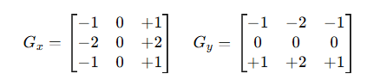

### **Properties:**

* More accurate than the Prewitt operator.
* Better noise suppression due to the weighted central pixel.
* Commonly used in edge detection applications.

## **4. Second Derivative Method for Edge Detection**

Unlike first-order derivative methods (Roberts, Prewitt, Sobel), **second derivative methods** (such as the **Laplacian operator**) focus on detecting **rapid intensity changes** in an image.

### **Laplacian Operator:**

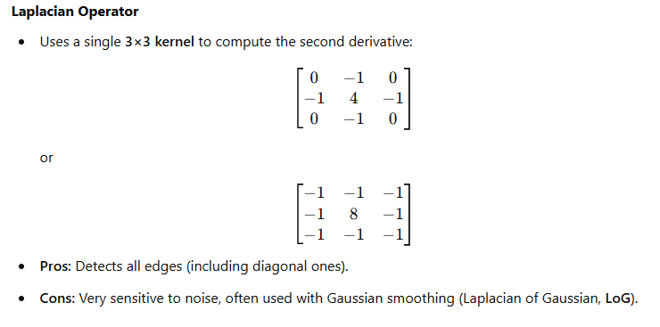

### **Properties:**

* Detects both horizontal and vertical edges.
* Sensitive to noise (often used with Gaussian smoothing).
* Highlights fine details but lacks directionality.

## **5. Canny Edge Detector**

The **Canny Edge Detector** is a multi-stage edge detection algorithm that improves accuracy and noise resistance.

### **Steps in Canny Edge Detection:**

1. **Noise Reduction:** Apply **Gaussian smoothing** to remove noise.
2. **Gradient Calculation:** Use **Sobel operators** to compute intensity gradients.
3. **Non-Maximum Suppression:** Thins out edges to retain only the strongest ones.
4. **Double Thresholding:** Classifies pixels into **strong**, **weak**, and **non-edges** based on intensity.
5. **Edge Tracking by Hysteresis:** Retains **weak edges** only if they connect to **strong edges**.

### **Properties:**

* Highly effective and widely used in real-world applications.
* Reduces noise and detects edges with high precision.
* Computationally expensive compared to simpler operators.

### **Comparison of Edge Detection Methods**

| **Method** | **Kernel Size** | **Noise Sensitivity** | **Edge Direction** | **Computational Cost** |
| --- | --- | --- | --- | --- |
| Roberts | 2×2 | High | Diagonal | Low |
| Prewitt | 3×3 | Moderate | Horizontal/Vertical | Moderate |
| Sobel | 3×3 | Low (Better smoothing) | Horizontal/Vertical | Moderate |
| Laplacian | 3×3 or 5×5 | High | Omni-directional | Moderate |
| Canny | Adaptive | Low (Gaussian filter) | All directions | High |

These techniques play a crucial role in image processing applications like object detection, feature extraction, and image enhancement. 🚀